Celebrate Sunflowers
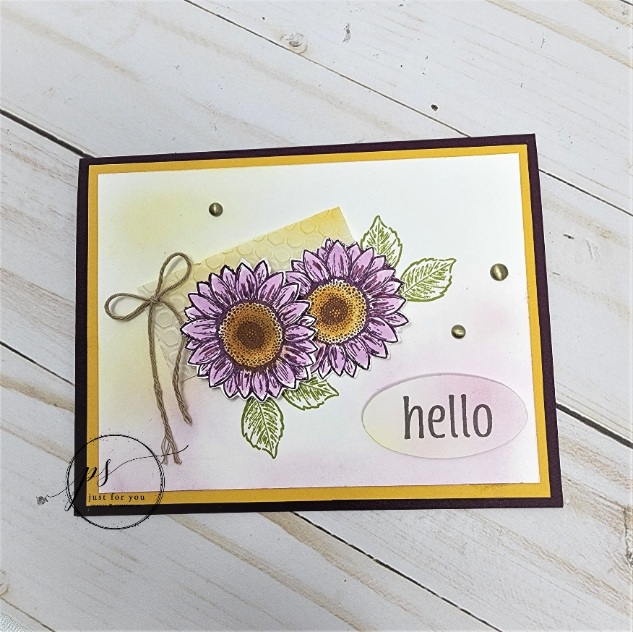

All images © 1990-2022 Stampin’ Up!®

Supplies:

- Stamp Set – Celebrate Sunflowers (152517), Artistically Inked (154542)
- Ink – Blackberry Bliss (147092), Crushed Curry (147087), Pear Pizzazz (147104), Basic Grey (149165) Classic Ink Pad
- Paper Blackberry Bliss (133675), Basic White (159276), Crushed Curry (131199), Vellum 8 ½” x 11” (101856) Cardstock (CS)
- Misc. –Multipurpose Liquid Glue (110755), Paper Trimmer (159392), Paper Snips (103579), Brushed Metallic Dots (156506), Baker’s Twine Essentials Pack (155475), Stampin’ Cut & Emboss Machine (149653), Sunflowers Dies (152704), Hive 3D Embossing Folder (157955), Stampin’ Dimensionals (104430), Blackberry Bliss (154877), Fresh Freesia (155518) Stampin’ Blends, Sponge Daubers (133773), Blending Brushes (153611), Double Oval Punch (154242)

Measurements:

- Blackberry Bliss CS – 8 ½” x 5 ½”, scored at 4 ¼” to form card base
- Crushed Curry CS – 5 ¼” x 4”
- Basic White CS – 5” x 3 ¾”, 4” x 4” – for stamping and die-cutting 2 sunflowers, scrap for stamping and punching sentiment
- Vellum – 2 ½” x 1 ¼”
- Twine (Crumb Cake) – 8”

Instructions:

- Using Liquid Glue, add Crushed Curry CS layer to card base.
- Using Blackberry Bliss Ink and small sunflower image, stamp 2 sunflowers on smallest white piece (stamp off once after inking up stamp for each image). Using Blackberry and Freesia Blends, color in sunflower petals as desired. Using Curry ink and Sponge Dauber, color centers.
- Die-cut each sunflower using small sunflower die. Using Paper Snips, carefully cut off leaves from images and set the sunflowers aside (leaves won’t be used).
- Using Hive 3D Embossing Folder, run piece of vellum through Cut & Emboss Machine. Using Blending Brush and Curry ink, add color as desired to embossed piece. Set aside.
- Using Curry and Blackberry inks, apply color as desired to white layer using Blending Brushes. Start off the CS and work onto white piece. (TIP: you can add color if too light but can’t remove if too dark).
- Adhere layer from #5 to card base.
- Using liquid glue, adhere vellum piece to white layer at an angle.
- Lay sunflowers on top of white layer to see where the leaves for each should be stamped. Hold up edge of sunflower that will be on the bottom and, using Pear Pizzazz ink, stamp leaves. Do the same thing to stamp leaves for sunflower on top.
- Once leaves are stamped, use liquid glue to adhere bottom sunflower onto card and then position the 2nd sunflower on top using Stampin’ Dimensionals.
- Adhere 3 Brushed Metallic Dots as desired.
- Using piece of Crumb Cake twine, tie bow and adhere to card front using small dab of liquid glue. Cut ends and fray.
- Using “hello” from Artistically Inked and Basic Grey ink stamp onto white scrap and punch out using smallest oval punch.
- Apply Curry and Blackberry ink on top of stamped oval using Blending Brushes. Adhere to card using Stampin’ Dimensionals.

