Santa’s Delivery
All images © 1990-2022 Stampin’ Up!®

Supplies:

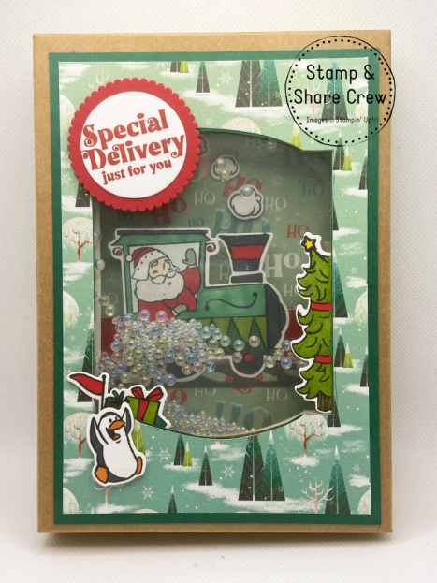
- Stamp Sets: Santa’s Delivery (159583) or discounted as a bundle with the Santa’s Train Dies (159590)
- Card Stock and Paper: Basic White (159276); Real Red (102482); Shaded Spruce (146981); Basic Gray (121044); Santa Express 12” x 12” Designer Series Paper (DSP) (159582); Window Sheets (142314); Kraft Gift Boxes (156569)
- Stamp Pads: Tuxedo Black Memento Ink Pad (132708), Real Red Classic Stampin’ Pad (147084)
- Tools: Santa’s Train (159589); Layering Circles Dies (151770); Lovely Labels Pick A Punch (152883); Stampin’ Cut & Emboss Machine (149653); Bone Folder (102300); Paper Snips (103579); Paper Trimmer (152392)
- Stampin’ Blends Combo Pack Markers: Poppy Parade (154958); Shaded Spruce (154903); Granny Apple Green (154885); Pumpkin Pie (154897); Petal Pink (154893); Daffodil Delight (154883); Soft Suede (154906); Basic Black (154843); Mint Macaron (154889); Pool Party (154894)
- Miscellaneous: Effervescent Elements (158789); Wink of Stella Clear Glitter Brush (141897); Foam Adhesive Strips (141825); Stampin’ Dimensionals (104430); Mini Stampin’ Dimensionals (255209); Stampin’ Seal Adhesive (152813); Tissue Paper; Pencil

Measurements:

- Basic White: 4 ½” x 6 3/8” (Cut 2); ¾” x 3 ½”; 4” x 6”
- Shaded Spruce: 4 ¼” x 6”
- Real Red: 4 ¼” x 6 1/8”
- Basic Gray: ½” x 3 ¾”
- DSP Tree Pattern: 4” x 5 ¾”
- DSP “Ho Ho Ho” Pattern: 3 ¾” x 5”
- Tissue Paper: 4 5/8” x 6 ½”
- Window Sheet: 3 ¾” x 5”

Instructions:

- Fold the Kraft Gift Box along the score lines and remove adhesive to make into box.
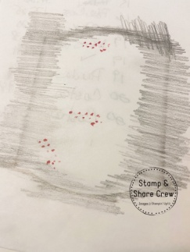
- Place the tissue paper over the front of the Kraft Gift Box front. With the side of a pencil, brush back and forth over the edge of the “window” on the box so you can create a template of the window. (See picture.) Cut out the center of the template.
- Attach the Tree Pattern DSP to the Shaded Spruce piece.
- Center the template over the Tree Pattern/Shaded Spruce piece and draw the window section with the pencil. Cut out.
- Attach to the front of the Kraft Gift Box.
- Center the template over one 4 ½” x 6 3/8” Basic White piece and draw the window section with the pencil. Cut out.
- Remove the clear protective sheet from the inside of the window on the Kraft Gift Box.
- Take strips of the Adhesive Strips and place just to the outside of the window on the inside of the Kraft Gift Box.
- Pour a small amount of Effervescent Elements into the window area.
- Remove the backing on the adhesive strips and place the 3 ¾” x 5” Window Sheet down to close the shaker area.
- Double stack Stampin’ Dimensionals along the top and bottom of the 4 ½” x 6 3/8” Basic White piece that has the window cut out. Attach to inside of Kraft Gift Box to hide the adhesive strips.
- Die cut a 1 ¾” Scallop Circle from near the top of the 4 ¼” x 6 1/8” Real Red piece. Set scalloped circle aside for later.
- Attach the 3 ¾” x 5” “Ho Ho Ho” Patterned piece to the Real Red piece.
- Place DSP/Real Red piece into cutter with blade location 1” up from the bottom of the DSP piece. Cut slit from the left edge of the DSP to the right side to create a slit for holding the gift card.
- Attach the DSP/Real Red piece to the second 4 ½” x 6 3/8” Basic White piece along the top, left side, right side, just above the slit and at the very bottom edge leaving the slit area without adhesive. (Test using a gift card.)
- Attach Basic White/Real Red/DSP piece to the inside of the box.
- Using Real Red ink, stamp “Merry Christmas” on the ¾” x 3 ½” Basic White piece. Punch both ends using the Lovely Labels Pick A Punch. Attach to inside of box at the bottom using Dimensionals.
- Die cut the ½” x 3 ¾” Basic Gray piece with the railroad track die. Attach to inside of box just below the slit.
- On 4” x 6” Basic White piece, stamp penguin, gifts, tree, train engine and smoke puffs using Memento Black ink. Die cut all pieces.
- Stamp “Special Delivery…” using Real Red ink. Die cut using 1 3/8” Layering Circle die. Attach to Real Red scalloped circle and attach to front of box using Dimensionals making sure the Dimensionals are not seen from the inside of the window.
- Color the pieces and assemble as follows:
  - Penguin: Color with Light Pumpkin Pie and Light Basic Black Blends Markers.
  - Gifts: Color using Dark Poppy Parade, Dark Granny Apple Green and Dark Shaded Spruce Blends Markers. Place adhesive on the back and slide into bottom left corner of the front of the box.
  - Tree: Color using Dark Daffodil Delight, Dark Granny Apple Green, Dark Poppy Parade and Light Soft Suede Blends Markers. Place adhesive on the back and slide into right side of the front of the box.
  - Train Engine: Color using Dark Poppy Parade, Light Pool Party (behind Santa), Dark Mint Macaron (mittens), Light Shaded Spruce, Dark Granny Apple Green, Dark Shaded Spruce and Light Basic Black. Place 3 Dimensionals on the back of the train just below the center line of the train. Attach to your gift card and slide gift card into slot.
- Attach smoke puffs to inside of box using Mini Dimensionals above the smoke stack of the train engine making sure the puffs go in the correct direction.
- Color Santa’s beard and eyebrows with Wink of Stella Glitter Brush.

