**Friends For Life**

All images © 1990-2024 Stampin’ Up!®

**Supplies:**

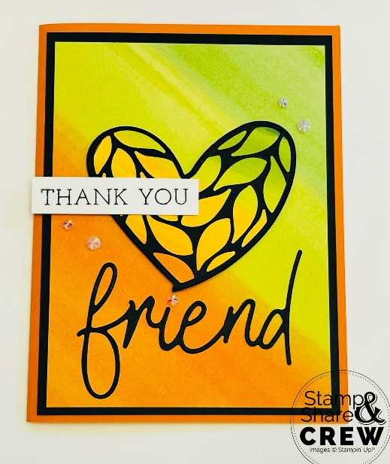

* **Stamp Set*:*** Friends For Life Bundle (163365)
* **Card Stock and Paper:**

Basic Black (121045), Basic White (159276),

Full of Life DSP (163357), Pumpkin Pie (105117)

* **Ink:** Tuxedo Black Memento (132708)
* **Tools:** Bone Folder (102300); Paper Snips (103579), Paper Trimmer (152392), Stampin’ Cut & Emboss Machine (149653)
* **Miscellaneous:** Adhesive Sheets (152334), Iridescent Faceted Gems (163368), Stampin’ Dimensionals (104430), Stampin’ Seal Adhesive (152813)

**Measurements:**

* Pumpkin Pie Cardstock: 5 ½” x 8 ½”; score at 4 ¼” and fold to form card base.
* Basic Black Cardstock: 4” x 5 ¼”, 2 ¾” x 5 ½” for die cut heart and “friend”
* Adhesive Sheets: 2 ¾” x 5 ½”
* Full of Life DSP: 3 ¾” x 5” and 2 ¾” x 3” for die cut heart
* Basic White Cardstock: ½” x 2 ½” for sentiment, and 4” x 5 ¼” (for inside)

**Instructions:**

1. Cut each piece listed in the measurements above.
2. Fold Pumpkin Pie Cardstock in half to form card base.
3. Adhere Basic Black cardstock layer to the card front.
4. Adhere Full of Life DSP layer to the card front.
5. Die cut solid heart from Full of Life DSP and adhere to the card front with Stampin’ Dimensionals.
6. Apply Adhesive Sheet to the back of the Basic Black cardstock piece then die cut the detailed heart and friend.
7. Remove adhesive backing from the die cut detailed heart and friend, and adhere them to the card front.
8. Stamp sentiment on a ½” strip of Basic White cardstock using Tuxedo Black Memento Ink; snip paper to size then adhere to the card front with Stampin’ Dimensionals.
9. Embellish card front with Iridescent Faceted Gems.
10. Adhere Basic White cardstock layer to the inside of the card.