**Saying Hey**

All images © 1990-2024 Stampin’ Up!®

**Supplies:**

* 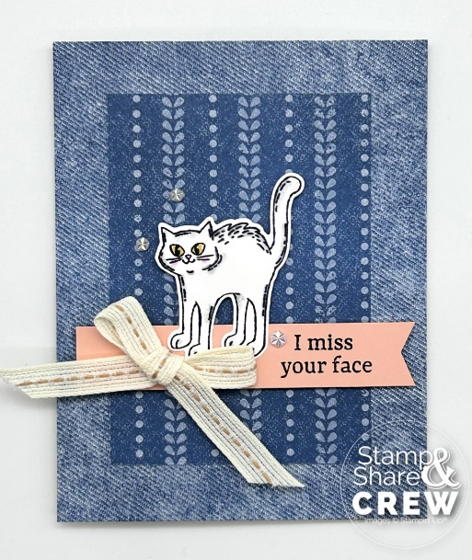**Stamp Sets*:*** Saying Hey(163697); Potions & Spells(164355)
* **Card Stock and Paper:** Basic Beige Cardstock (CS) (164511); Basic White CS (159276); Petal Pink CS (146985); Country Lace Designer Series Paper (DSP) (163415)
* **Stamp Pads:** Memento Black (132708)
* **Tools:** Stampin’ Blends in Bubble Bath (161675), Wild Wheat (161661), Smoky Slate (154904), and Color Lifter (144608); Potions & Spells Dies (164141)
* **Miscellaneous:** Pecan Pie Center Stripe Ribbon (162744); Iridescent Faceted Gems (163368); Paper Snips (103579); Mini Glue Dots (103683); Stampin’ Dimensionals (104430); Mini Stampin’ Dimensionals (144108); Multipurpose Liquid Glue (110755)

**Measurements:**

* Basic Beige: 5 ½” x 8 ½”
* Basic White: 2” x 2 ½” for cat
* Petal Pink: 3 7/8” x ¾” banner
* Country Lace DSP: 4 ¼” x 5 ½” denim print
* Country Lace DSP: 3” x 4 ¼”

**Instructions:**

1. Score the Basic Beige card base on the long side at 4 ¼” and fold.
2. Attach the denim print DSP to the card front using liquid glue.
3. Attach the smaller piece of DSP on top of the denim print using liquid glue.
4. Using your paper snips make a banner cut on the right side of the Petal Pink strip. Then, stamp your sentiment using Memento Black ink and the Saying Hey stamp set.
5. Attach the Petal Pink banner to the card front about 1 ½” from the bottom using Stampin’ Dimensionals.
6. Stamp the cat using Memento Black ink on the piece of Basic White CS. Color the cat using Smoky Slate light and blend with the color lifter, Wild Wheat (for eyes), Bubble Bath (nose and cheeks).
7. Lastly, add a bow using a mini glue dot and 3 Iridescent Faceted Gems to the card front.