Winterly Tree Tops

All images © 1990-2024 Stampin’ Up!®

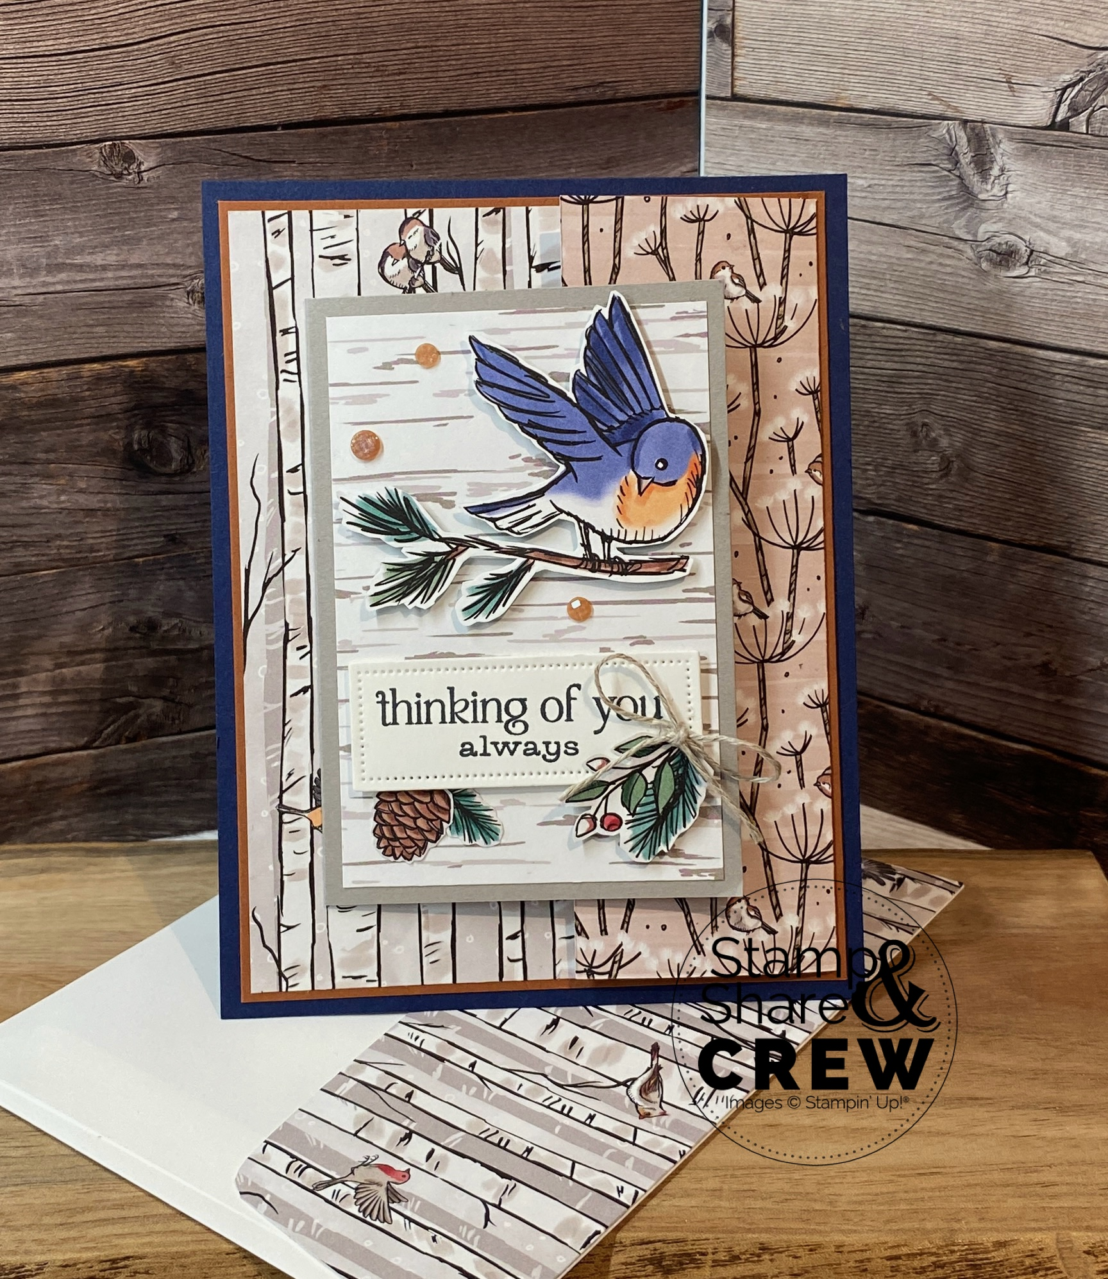**Supplies:**

* **Stamp Sets*:*** Winterly Tree Tops (164184)
* **Card Stock and Paper:** Night of Navy Card Stock or (CS) (100867); Copper Clay Card Stock (161721); Gray Granite Card Stock (146983); Basic White Card Stock (159276); Nests of Winter Designer Series Paper (DSP) (164183)
* **Stamp Pads:** Tuxedo Black Memento Ink (132708)
* **Tools:** Everyday Details Dies (162864)
* **Miscellaneous:** Earth Tones Shimmer Gems (164070); Linen Thread (104199); Stampin’ Dimensionals (104430); Multipurpose Liquid Glue (110755); Mini Glue Dots (103683)

**Measurements:**

* Night of Navy Card Stock: 4 1/4” x 5 1/2”
* Copper Clay Card Stock: 4” x 5 1/4”
* Gray Granite Card Stock: 4” x 5 1/2”

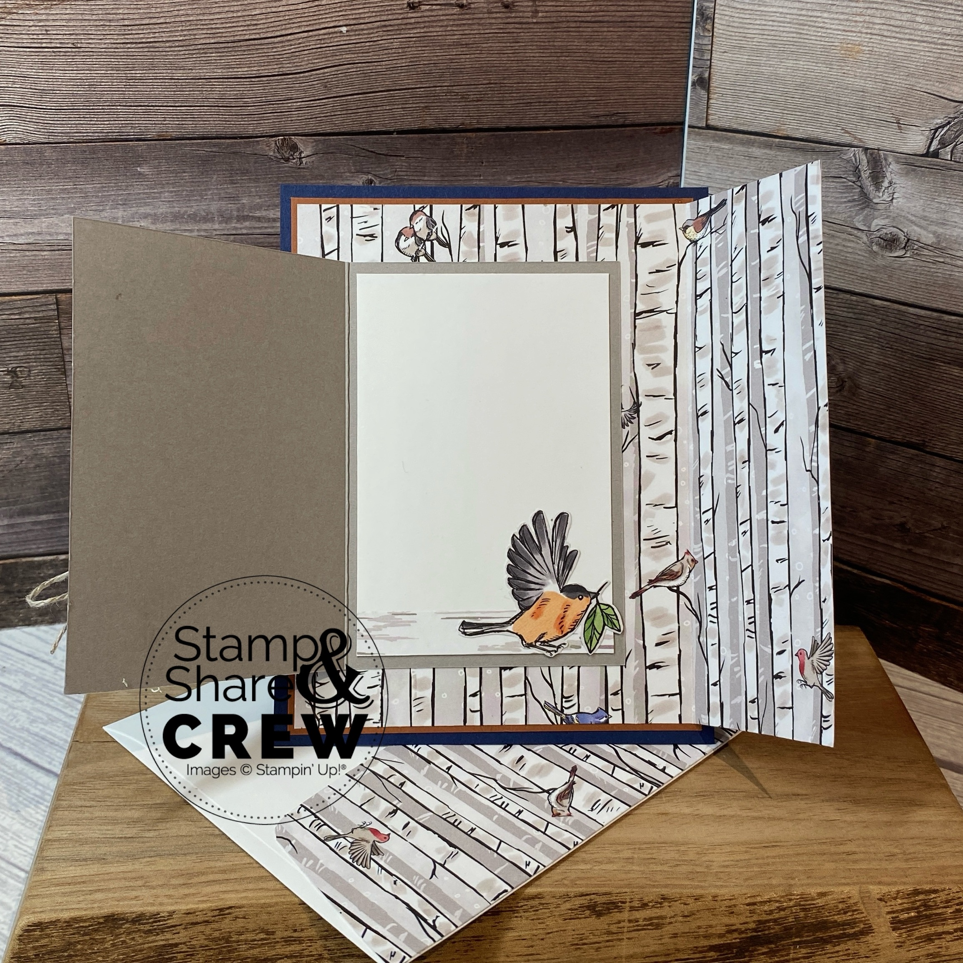

* Basic White Card Stock: 2 1/2” x 3 3/4”
* DSP: 5 1/8” x 5 5/8”, 2 1/2” x 3 3/4” (front panel), 1/2” x 2 1/2” (inside panel), 2 3/8” x 6” (envelope Flap), various images fussy cut
* Ribbon: 8” Linen Thread

**Instructions:**

1. Score Designer Paper on the 5 5/8” side at 1 3/4”, burnish the fold gently
2. Adhere Designer Paper to Copper Clay CS, adhere to Night of Navy CS
3. Score Gray Granite on the 5 1/2” side at 2 3/4”, adhere & center of the card front with the flap open (see second photo for placement)
4. Adhere 1/2” strip of designer paper to basic white card stock panel, adhere to inside of Gray Granite, fussy cut small small bird, adhere to inside
5. Adhere designer paper to front panel
6. Die cut label for greeting, adhere to front panel
7. Fussy cut various images, adhere a large bird to front panel, adhere small leaves & pinecones around label
8. Tie linen thread bow, adhere with mini glue dot
9. Embellish with Earth Tones Shimmer Gems
10. Adhere remaining designer paper to envelope flap, trim off excess